­­Micro Services With Boot

* Step 1 : create separate one rest api with port 9001 (i.e user microservice)
* Step 2: create separate one other rest api with port 9002 (i.e contact microservice)
* Step 3 : now for communication of both the service we need of RestTemplate
* so first of all declare the RestTemplate as bean in main file, so we can Autowired the our RestTemplate in user service
* using the RestTemplate we can communicate the both microservices

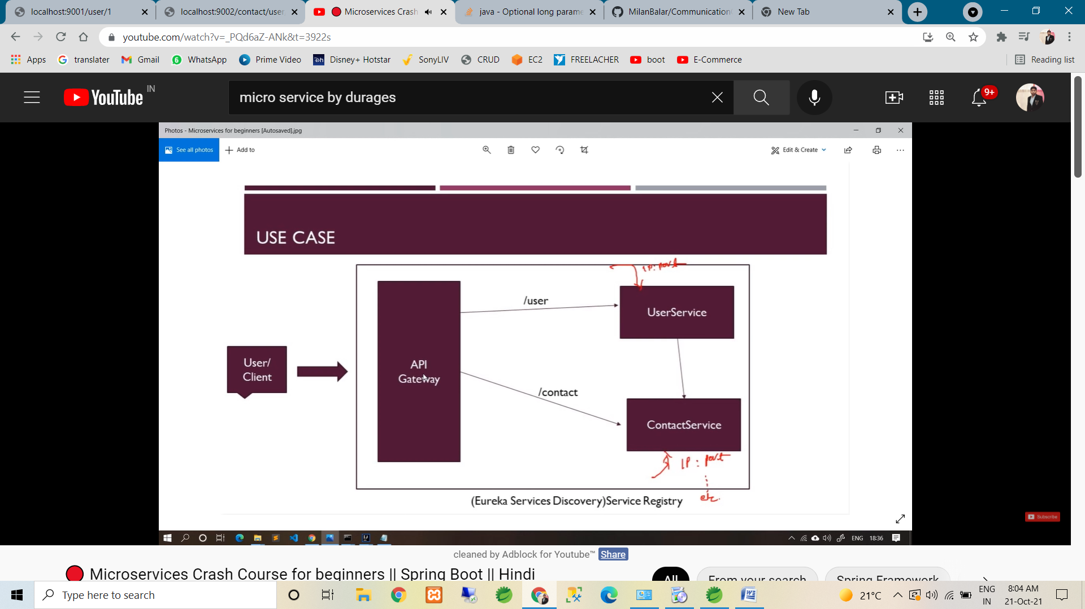

* Follow the above diagram for communication.
* For the communication of two microservice code is commit in git with repo name is :

<https://github.com/MilanBalar/CommunicationOfTwoMicroServiceBoot_v1.git>

* Step 4 : now we create Eureka service discovery (Eureka server)
* Now to create the our both micro service to client & register in to Eureka server
* The main purpose of Eureka server & client is our all client(microservices) register on one common place
* Then we create API gateway
* API gate way is use for :- we not need to call every services with is url & port.
* API gate way is endpoint of microservice. So using api gate way url we can call the our all the micro services.
* Step : 5 now we create Eureka server. It’s same as simple boot project.
* Crate spring boot project.
* Pom.xml in require dependency is: Eureka Server
* In main class we need to apply annotation : @EnableEurekaServer
* Application.properies : server.port =8761 (Eureka default port number)

: eureka.client.register-with-eureka=false (:. Means it’s indicate this application it self not register in Eureka).

: eureka.client.fetchRegistry : false

: eureka.server.waitTimeInMsWhenSyncEmpty: 0 (:. It’s just waiting time)

* If we fire the localhost:8761 so we can get the Eureka UI.
* Here we can see, no instance is are available. Because of still we not create any client .show the following attachment.
* 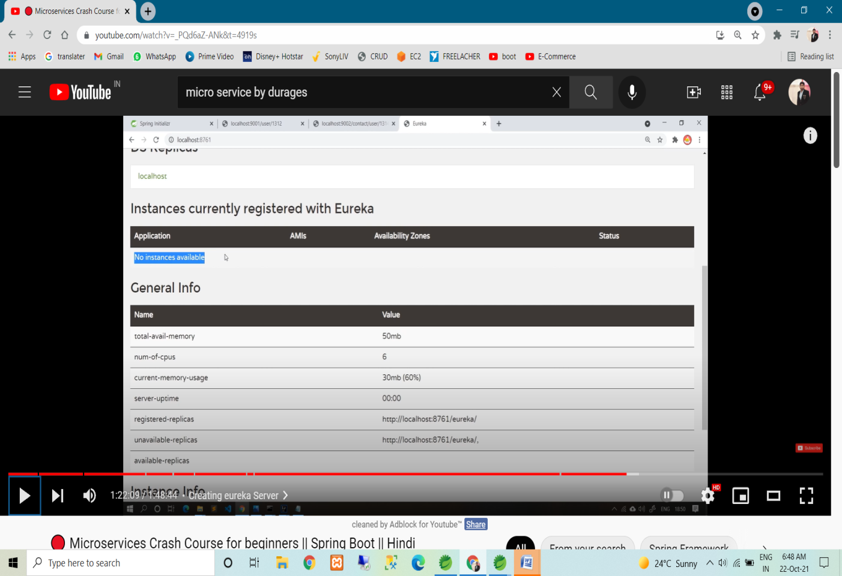
* So now we create the our both service as client.
* First we crate contact service as client
* We required Eureka discovery client dependency

-🡪 so go to spring initialize (like we create new project)& search the Eureka discovery client dependency dependency.

-🡪 now click on explore so we can get the dependency.

--🡪 following thing also need to copy

-> inside properties tag copy spring-cloud-version

-> & copy netfix-eurek-client dependency

-> & copy <dependencymanagement> whole tag

🡪 so now run the out project.

* If we check in eureka server**(:.http://localhost:8761/)** so we can got the instance of client service. Check the below image.

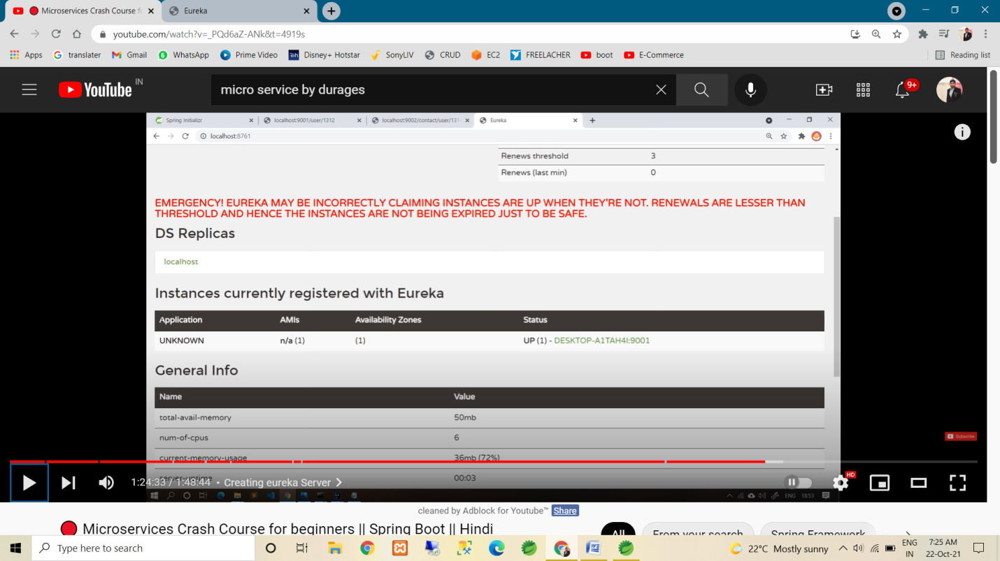

* Same step follow for create client to user service .
* As up the above pic application name is shown as UNKNOWN.
* So we to set the application name & IP (here above pic in show host name in place of IP in status tab)??

-🡪 first set in user-service

-> application.properties in

🡪 spring.appliction.name=user-service

-🡪 then run the code so now in Eureka server in we can

See the Application name as user-service.

-🡪 now we change the host name in user-service(in above pic inside the status colume, we want to shown the Ip)

->application.properties in

-> eureka.instance.hostname=localhost (:. Even we can also use this in Eureka server In properties).

-> same step apply in contact-service

🡪 now restart the all & show the below pic in Eureka server

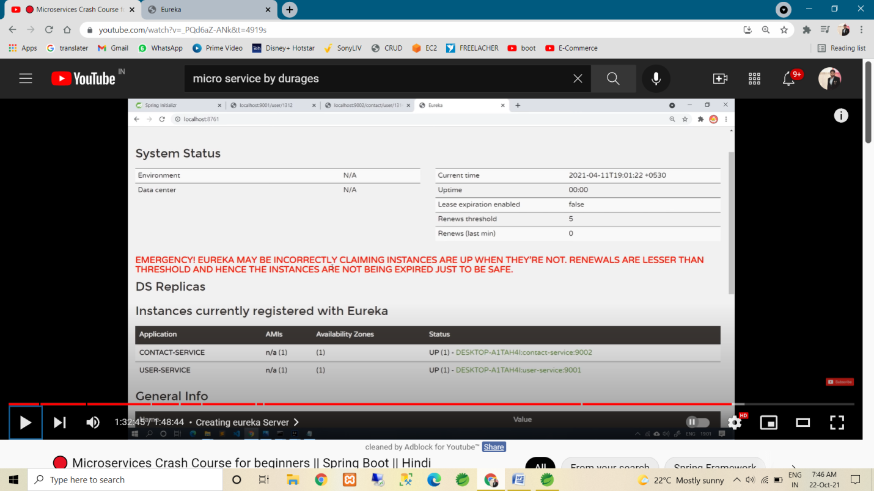

* Now our both service(eureka-client) registered on eureka server.
* Now we not need to URL(:. /localhost:port/) for calling the services. We can call using the application name(:. Show above pic).
* Now we require one annotation(:. In user-service only because is call the other service) :- @Loadbalanced (:. Above the RestTemple Bean (in main method))
* If we not use this annotation so we can get the :- UnKnownHostException.
* So we need to load balancing , so it’s resolved.
* Now we implement API Gateway
* API Gateway is endpoint of microservice.
* Main motto of API gateway is we not need to call every service manually. API gateway handle it.
* Here we can alos handle login, authentication etc.
* Refer below pic.

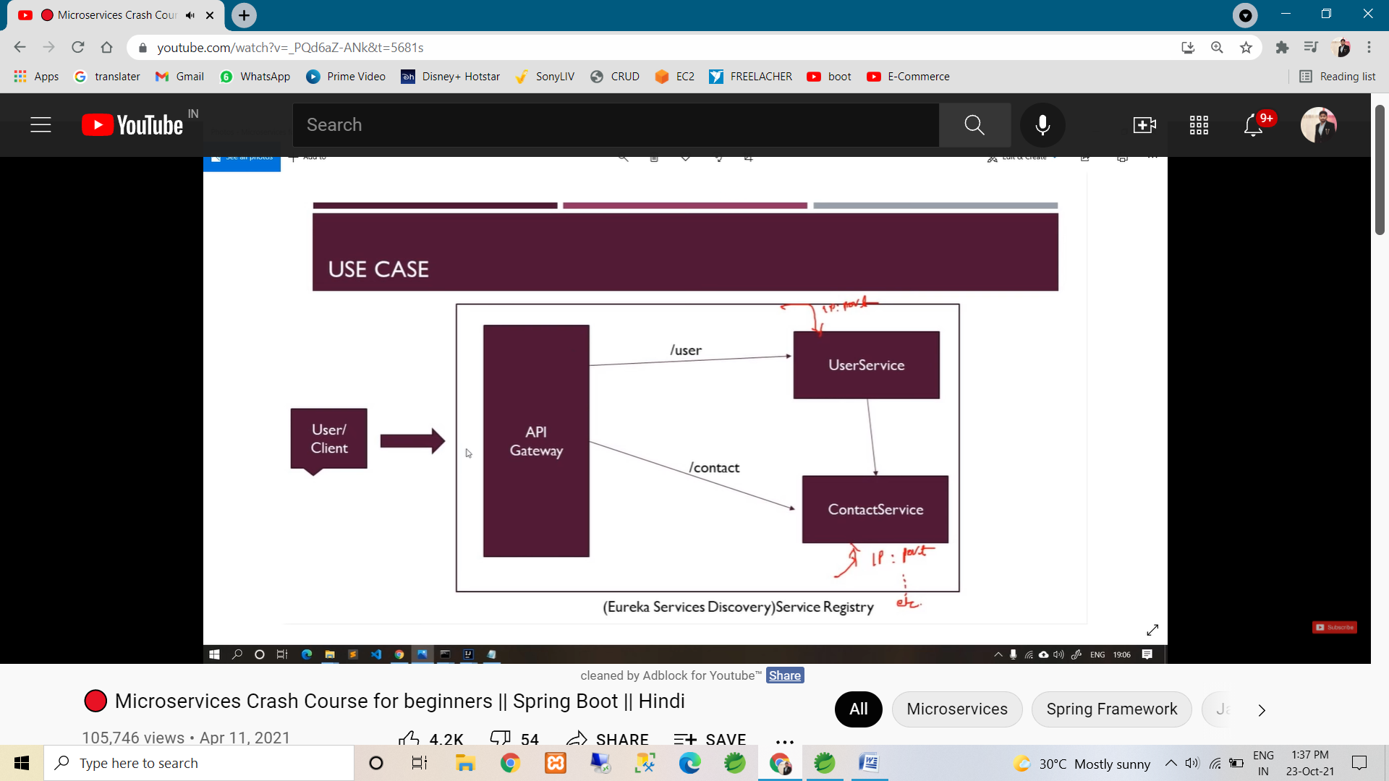

* STEPS for crerating API Gateway
* Create spring boot application.
* Pom : Spring cloud routing dependency (:. We can also create using Zuul dependency). & Eureka Discovery client dependency (:. Bcoz it’s also Eureka clinet)

& Spring Boot Actuator (:. It’s optional. It’s use for manage & monitor our application)

* As we know API gateway it’s also eureka client, so apply the @EnableEurekaClient in main method.
* Application.properties file in

--> server.port : 8999 (:. we can use any port nubmer).

🡪 eureka.instance.hostname: localhost

🡪 spring.application.name:api-gateway

& also refer the following application.yml(it’s same as application.properties, just we use ‘:’ symbol ) of API Gateway.

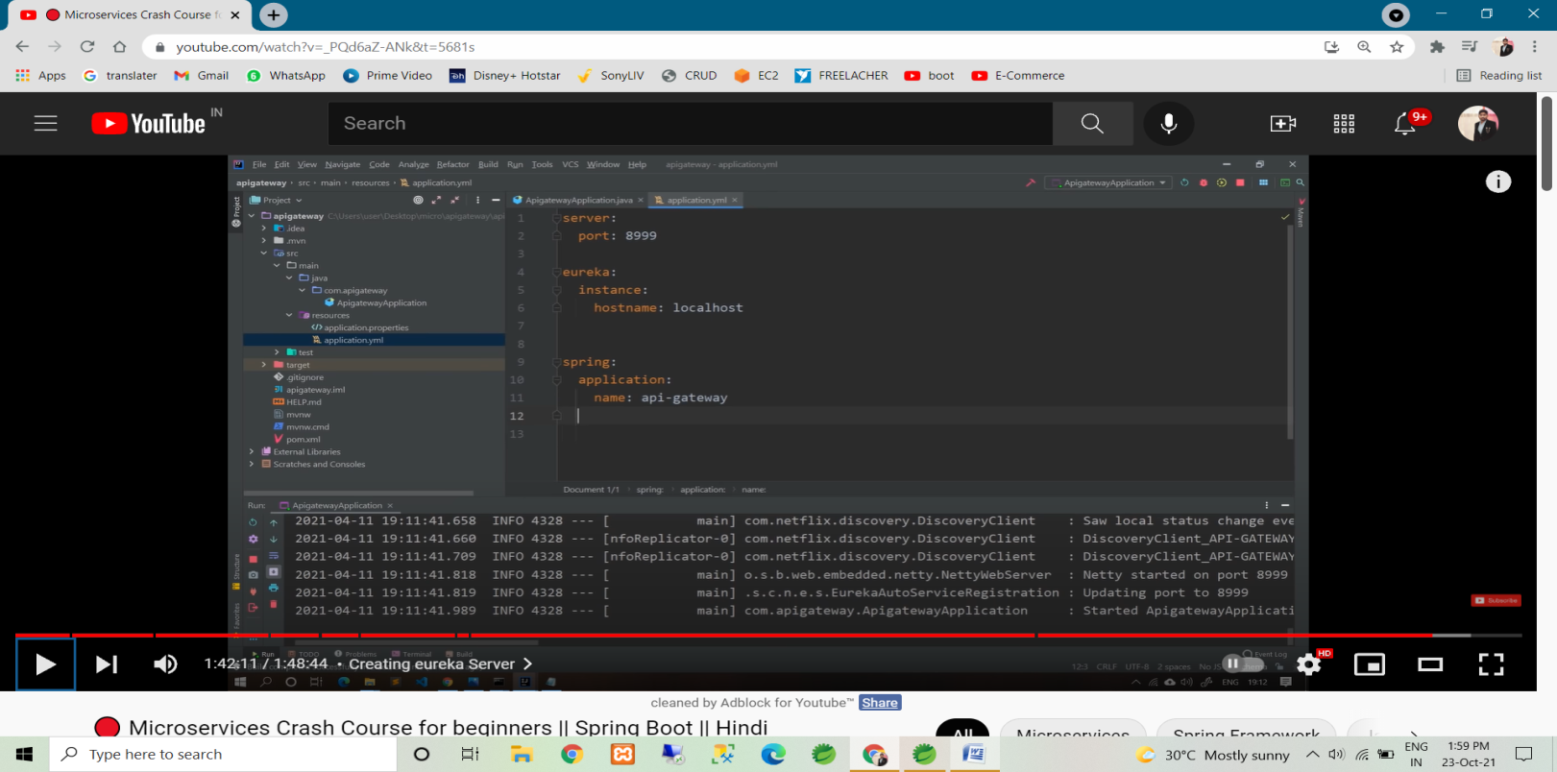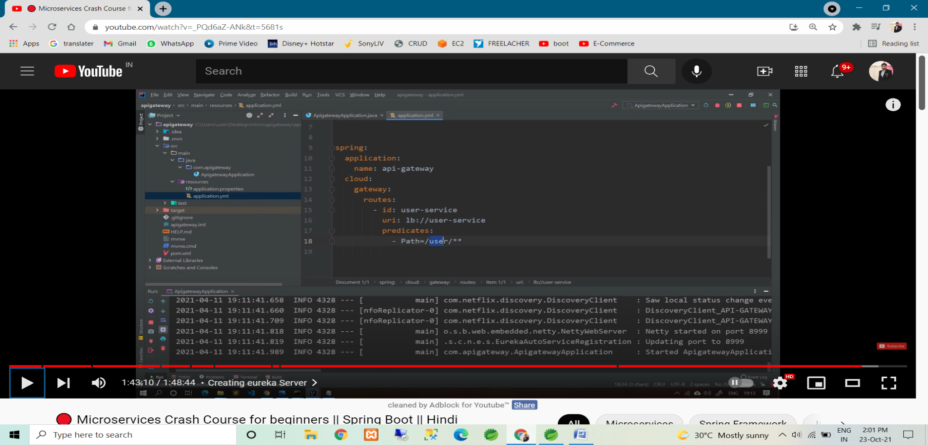

🡪above last pic in predicates indigate every request start’s with ‘/user/**’ it’s forwarded into ‘user-service’ uri. & in uri ‘lb’ use for load balancing then use our microservice name.

* Refer the following pic for configure contact service in api gateway.

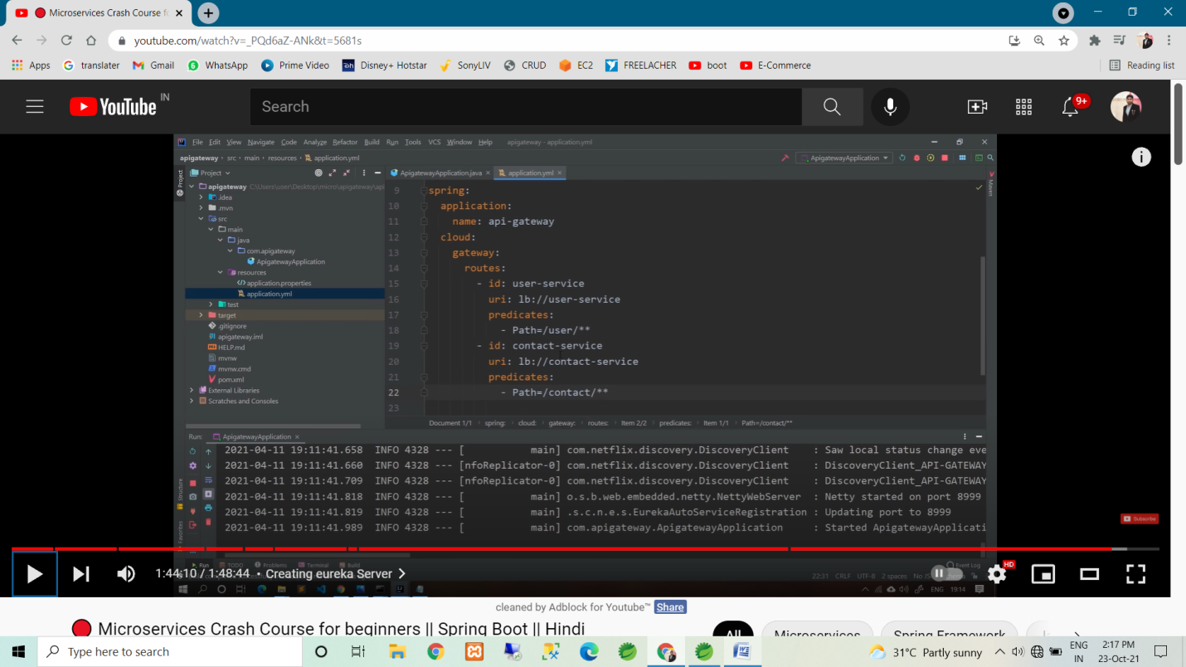

* So now we can access any microservice using api gateway url.
* i.e localhost:8999/user/2
* i.e localhost:8999/contact/user/4

# #### part -2 ####

### Hystrix library: in multiple microservice in, chances to any microservices is goes down.

So this library handle this failer.

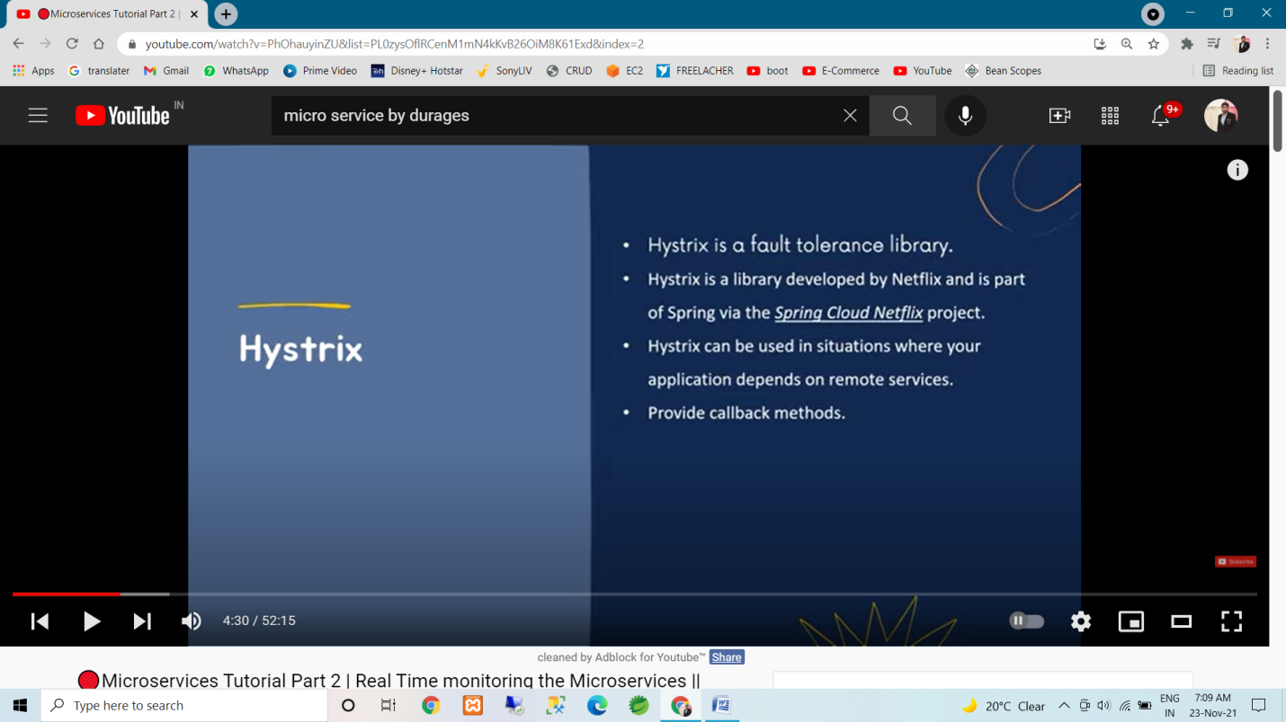

* implement the hystrix lib in project :-
* step 1 : add dependency of spring-cloud-starter-netflix-hystrix
* step 2 : configuration
* Hystrix dashboard : it’s monitor the services.
* Now implement the hystrix in our current project.
* Add dependency of spring-cloud-starter-netflix-hystrix in API Gateway project (2.3.4 version require of spring-boot-starter-parent)
* Also add actuator dependency in API Gate way Project.
* Now do configuration
* First we handle for user-service. So just add filter in application.properties.yml , as per the follow snap.

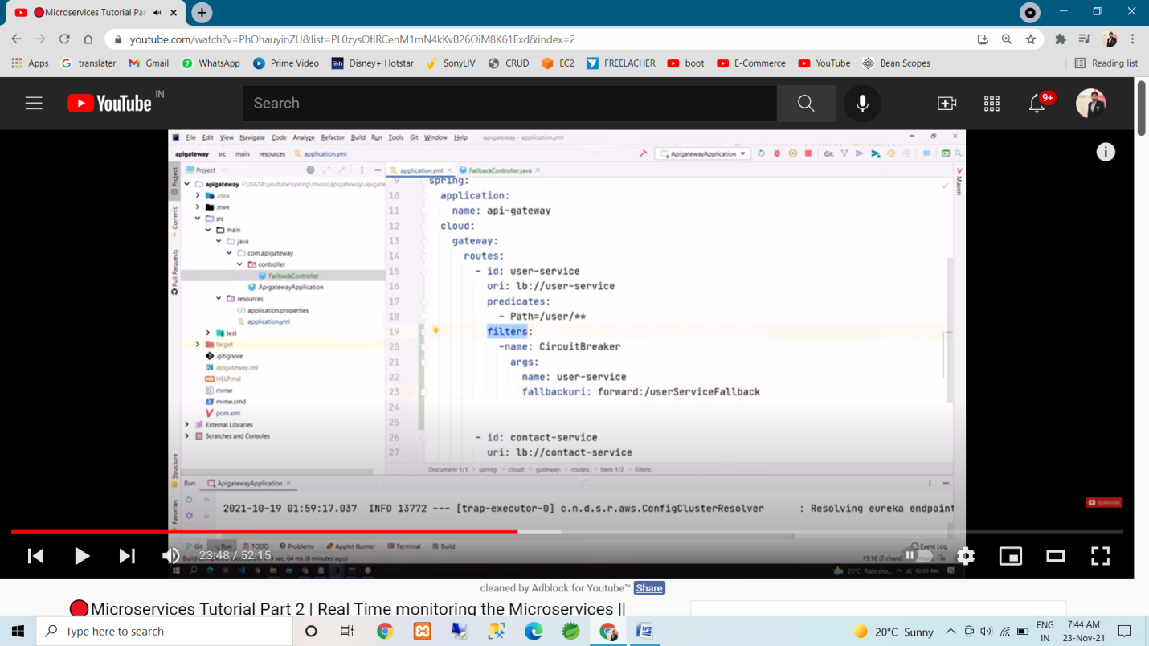

* If our user serice is goes down so url is redirect on userServiceFallback.
* So we handle this request in our API gate way project inside controller, as per the follow snap.
* 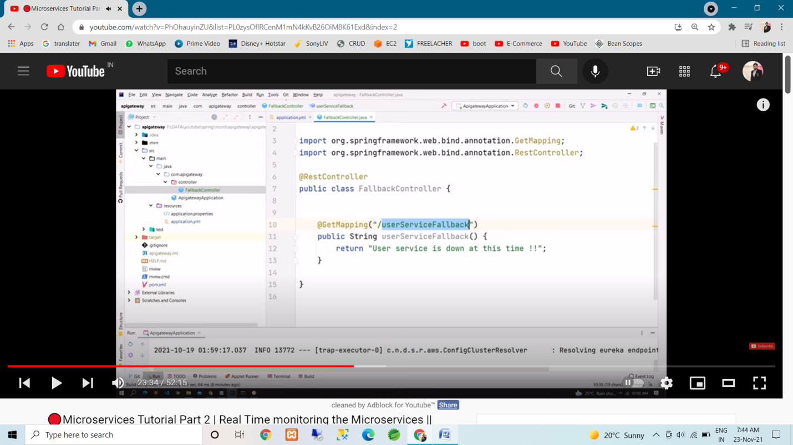
* Same as add filter for contact-service.

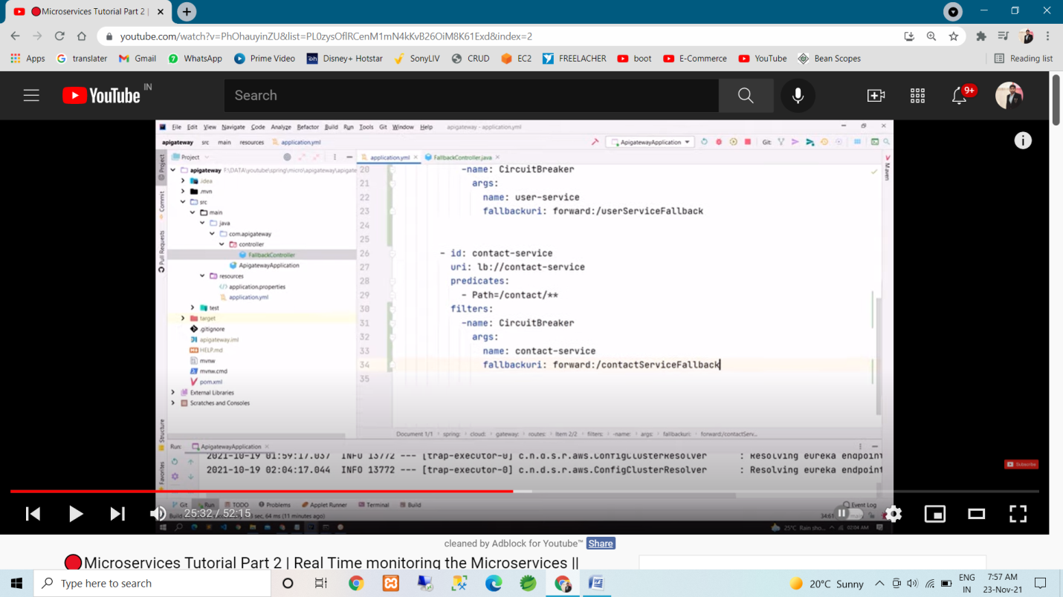

* And handle the fallback url as per the following snap.

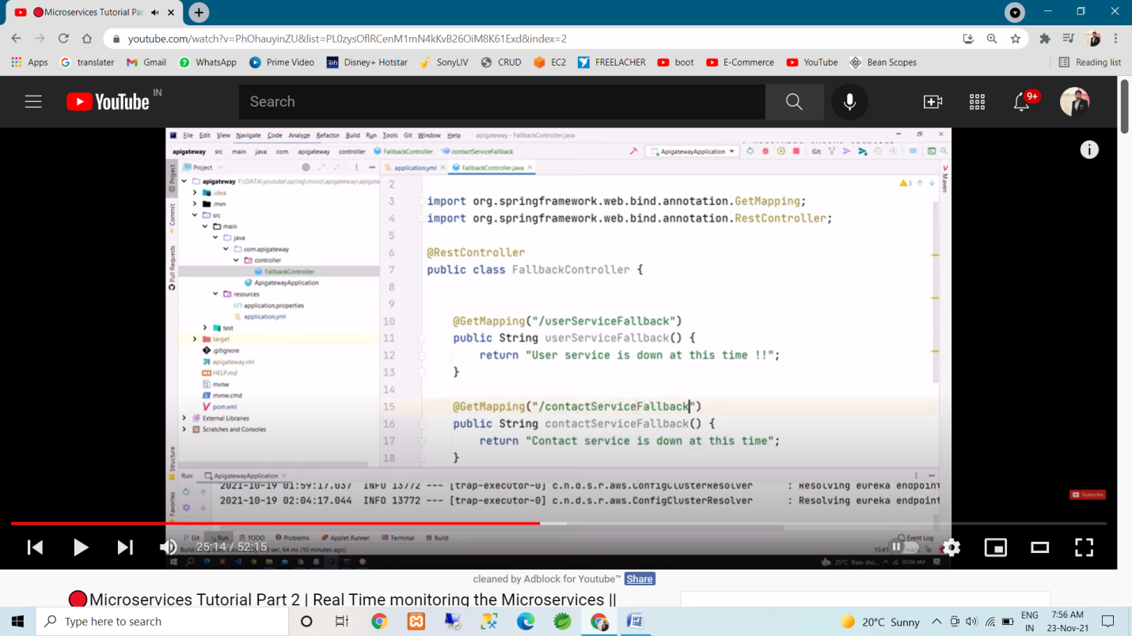

* now we add the time out. How many time it’s wait.

🡪 If 5 second in any service is not responding so it’s down, as per thr following configuration.

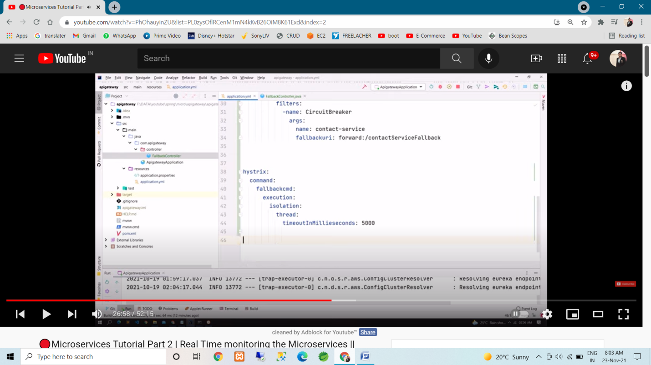

* now we enable the Stream. Hence hystrix dashboard monitor the stream.
* Refere following snap.

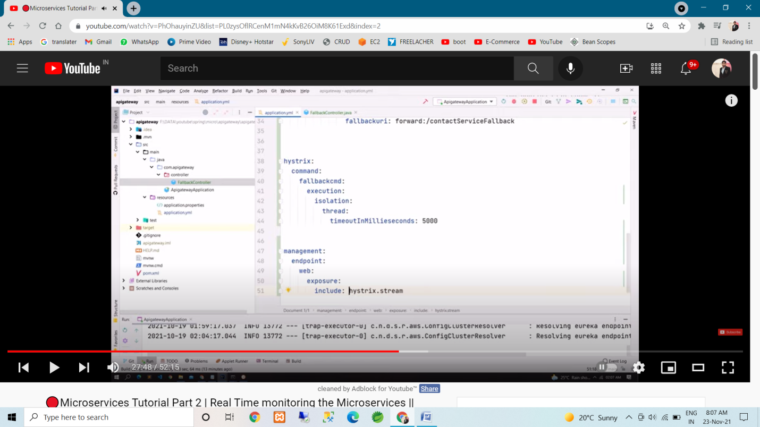

🡪 so now our Stream is enabled.

🡪 some changes : managemet:

endpoints:

-🡪 some change in above snap , just give the space in after name(:. Inside the filter ) PFA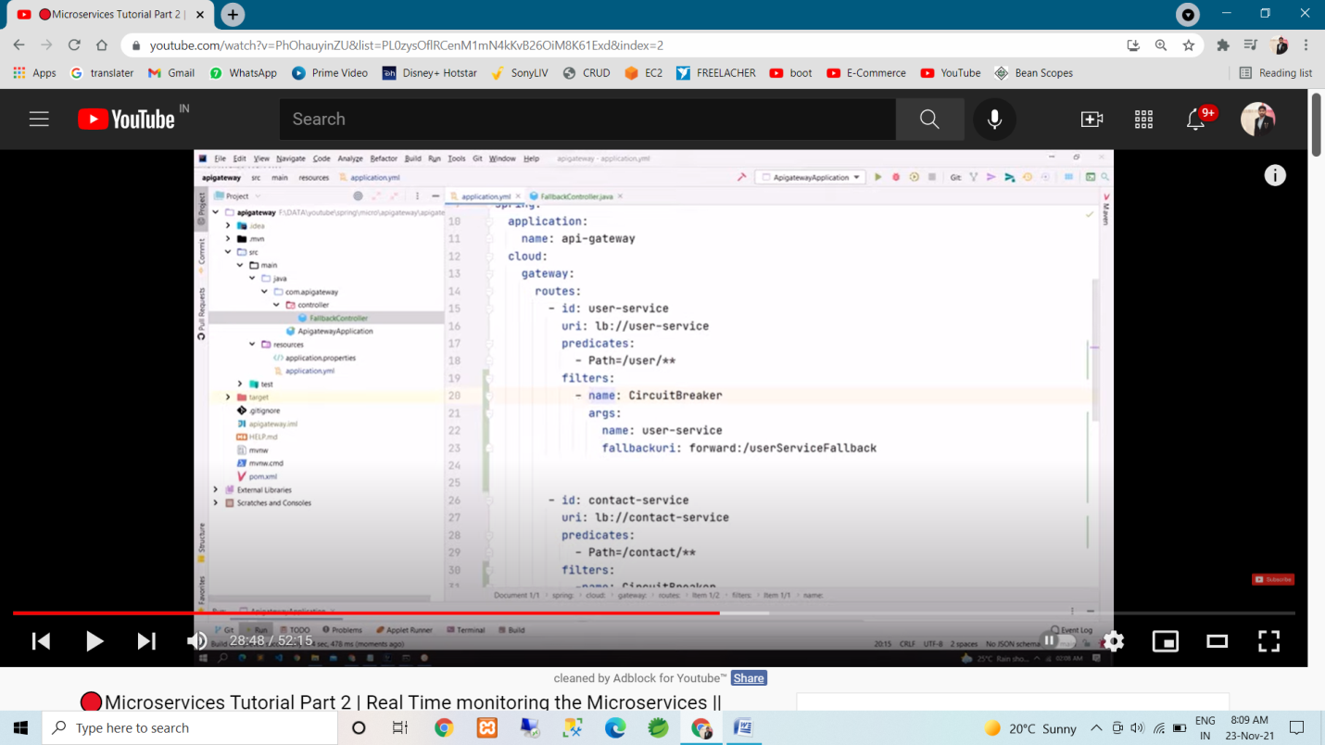

* Change the spring cloud version for the resolved error

2020.0.2 to Hoxton.SR8 && spring-boot-starter-parent version 2.3.4.RELEASE

-- so now all error is resolved. And project worked properly

-- add the annotation in main class of API gateway 🡪 @EnableHystrix

So hystrix is now enable.

## now crate Hystrix Dashboard pro­ject.

* Create new spring boot project for dashboard.
* Dependency : Spring Web, Eureka Discovry client (:. It’s also register in eureka server), spring-cloud-starter-netflix-hystrix-dashboard ,

add spring-cloud-version <properties> tag (:. <spring-cloud.version> 2020.0.4 </spring-cloud.version>) follow snap 1,

<dependencymanagemt> above the build (:. Same as we configured in user & contact micro service) follow snap 2

1.--> 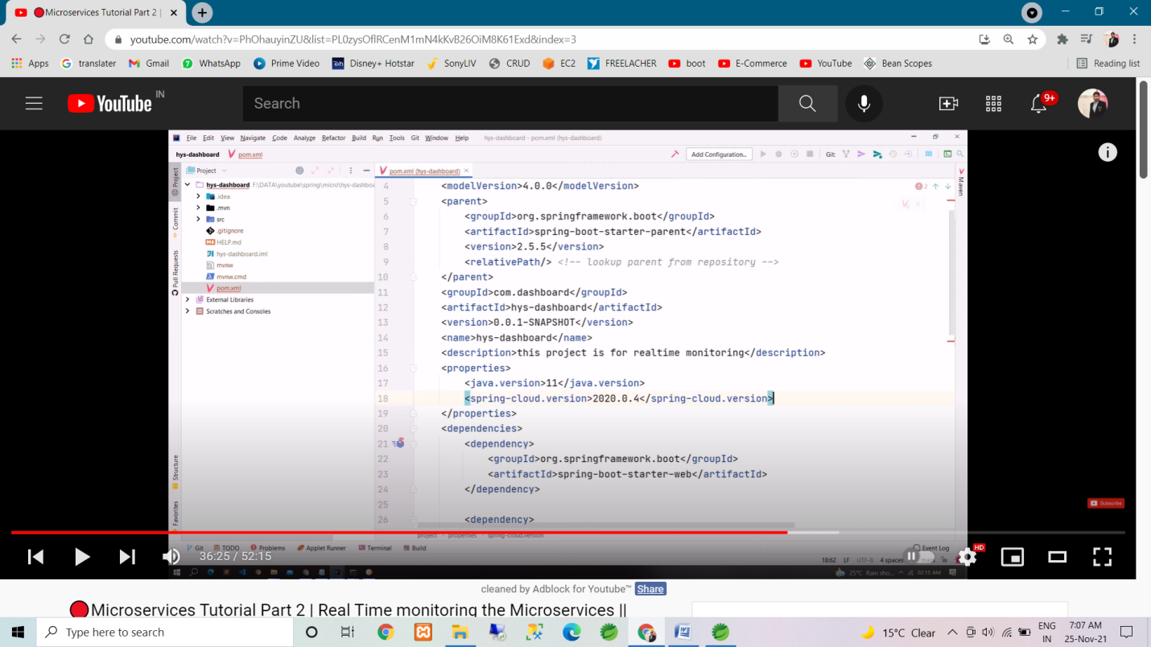

2 🡪 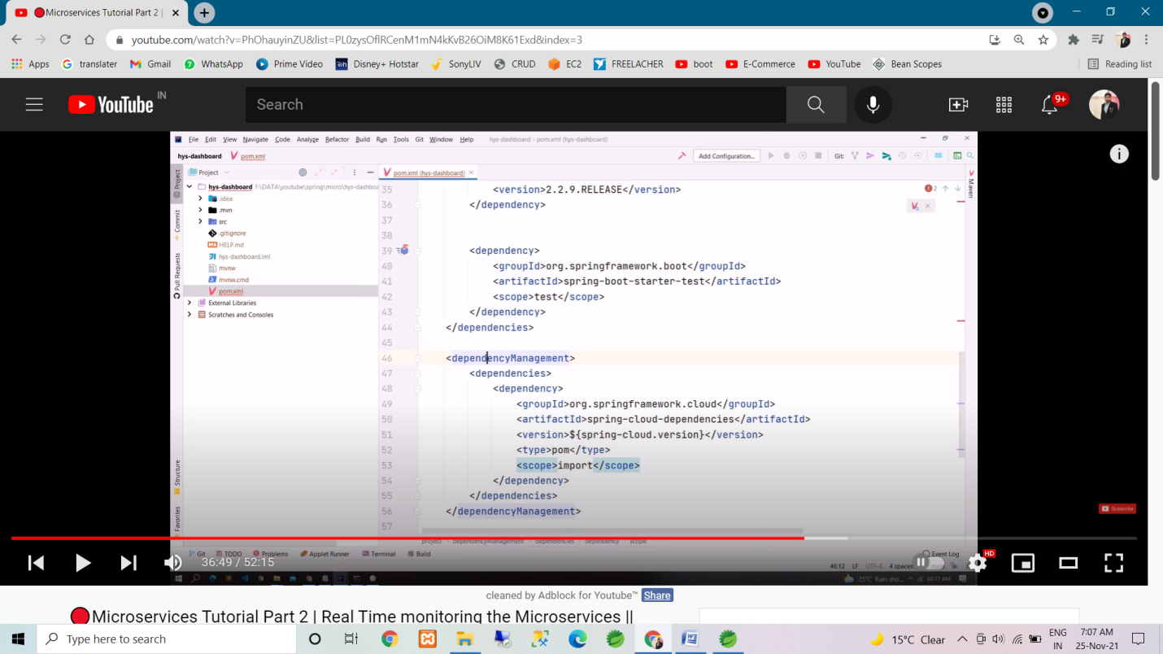

* Main class in add annotation -> @EnableEurekaClient (:. Cause it’s also eureka client). & @EnableHystrixdashBoard
* Add the following code in application.properties.

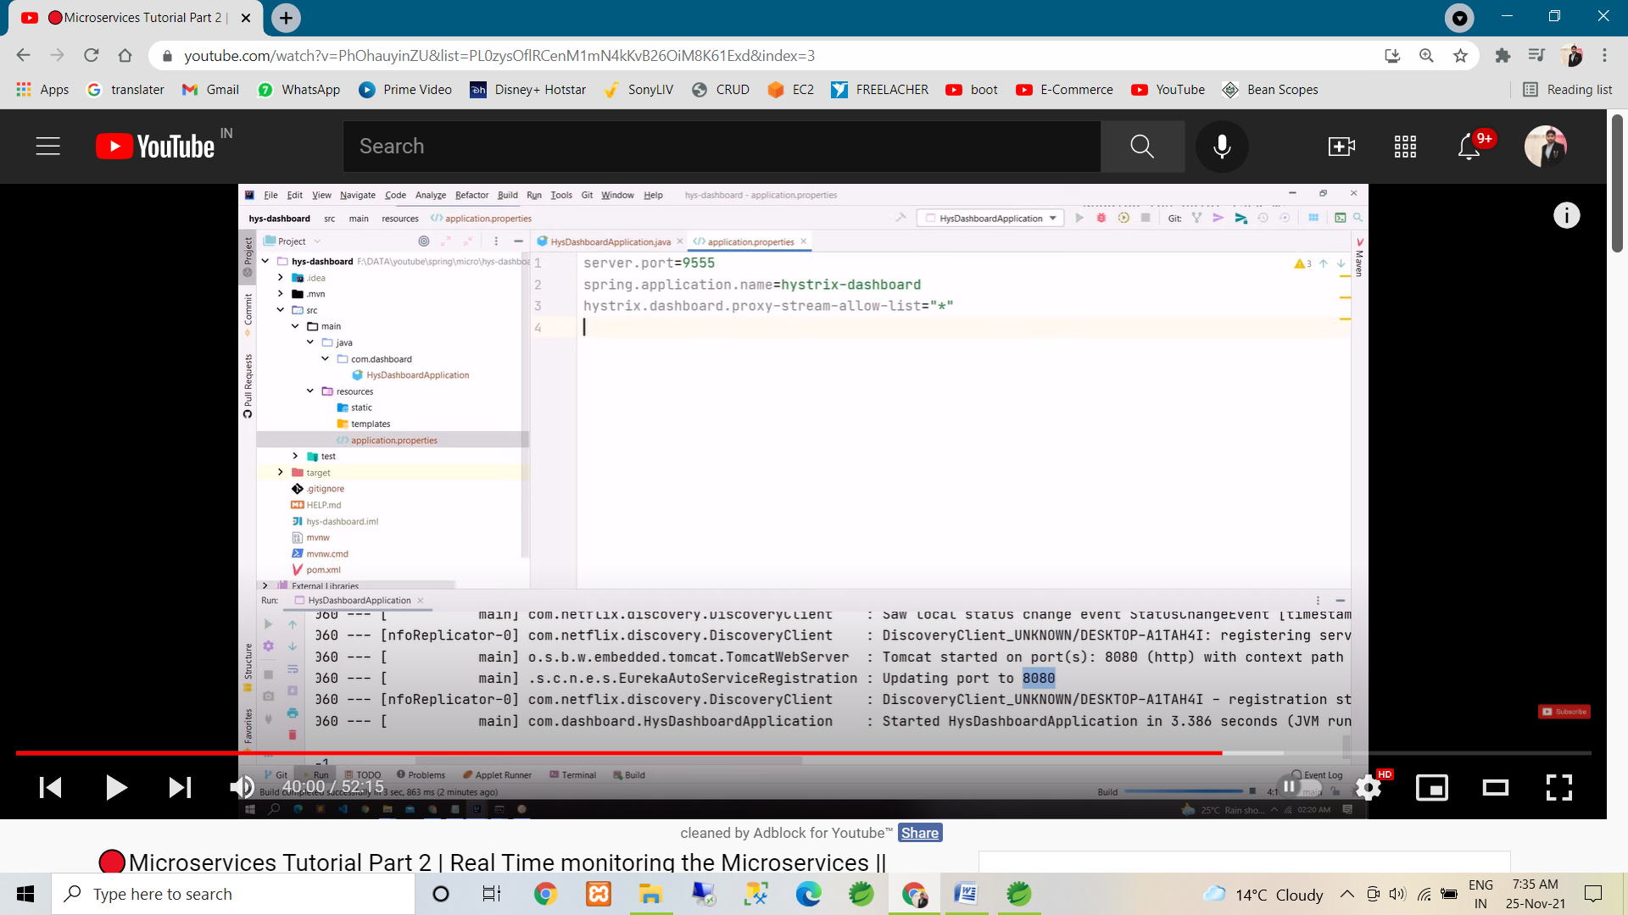

* Above snap in ‘ * ‘ means it’s allow all the proxy stream.
* Here we allow the proxy stream, hence it’s monitor all the stream

########### done ############

🡪 go to browser & fire the eureka server url.

* Here we show the all micro service on Eureka UI.
* Click on url against the Hystrix dashboard & fire request -🡪afterport number/hystrix . refer following snap.

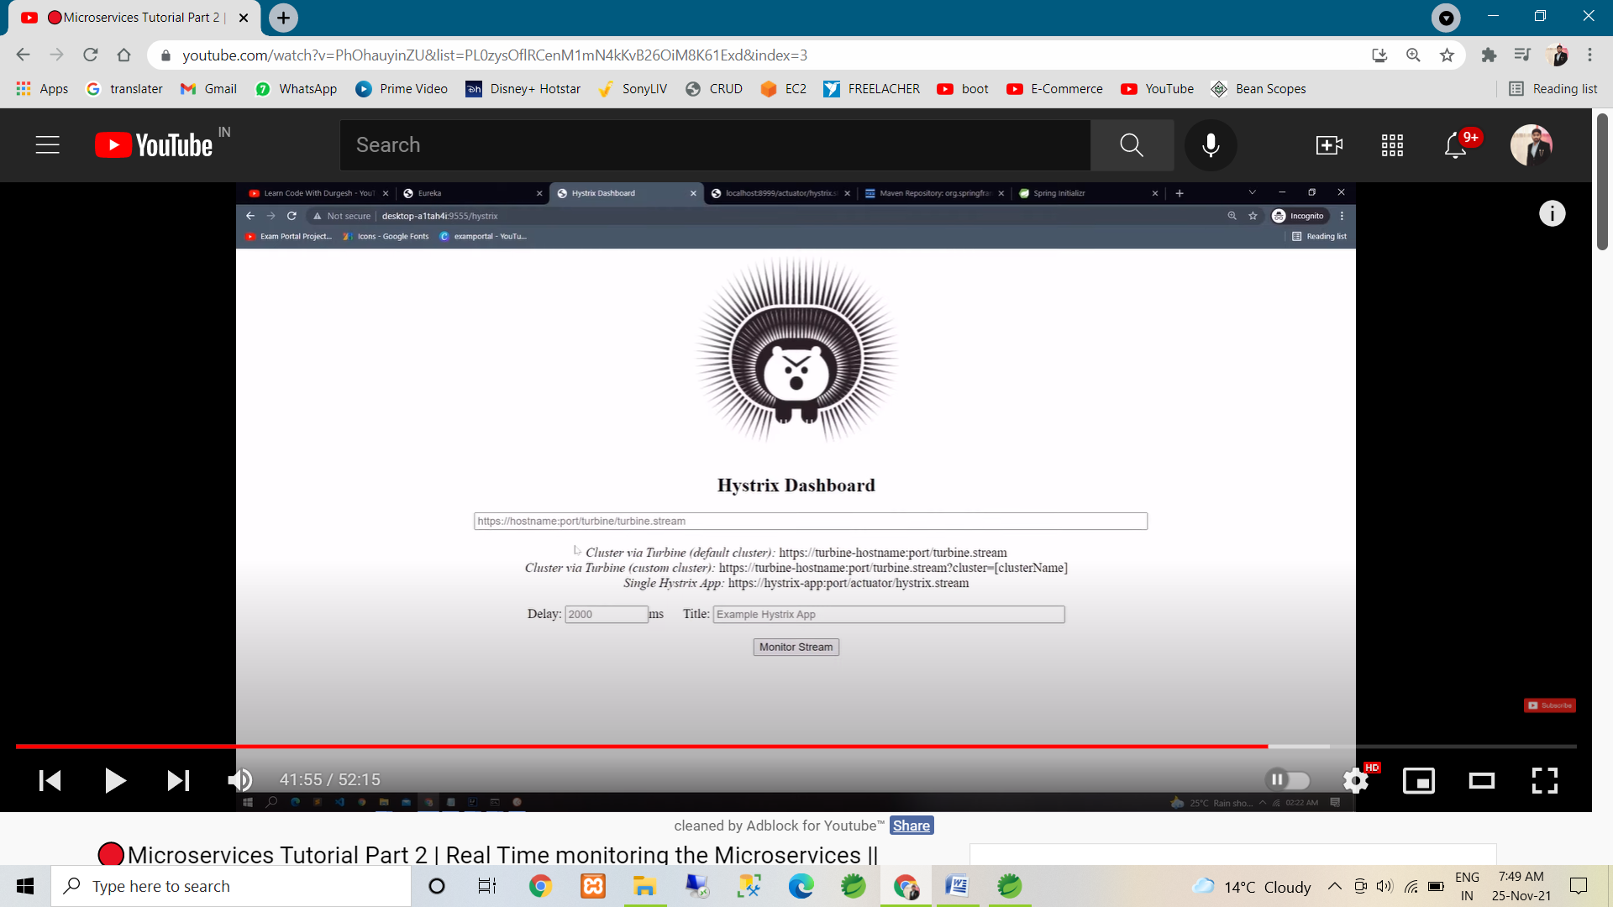

* Now check the stream

Click on the url against the API-Gateway.

And fire following url :- localhost:9978/actuator/hystrix.stream (:. Here 9978 is api gate way port number)

-- > in above url in we write hystrix.stream because we config it in api gate way.

Refer following snap.

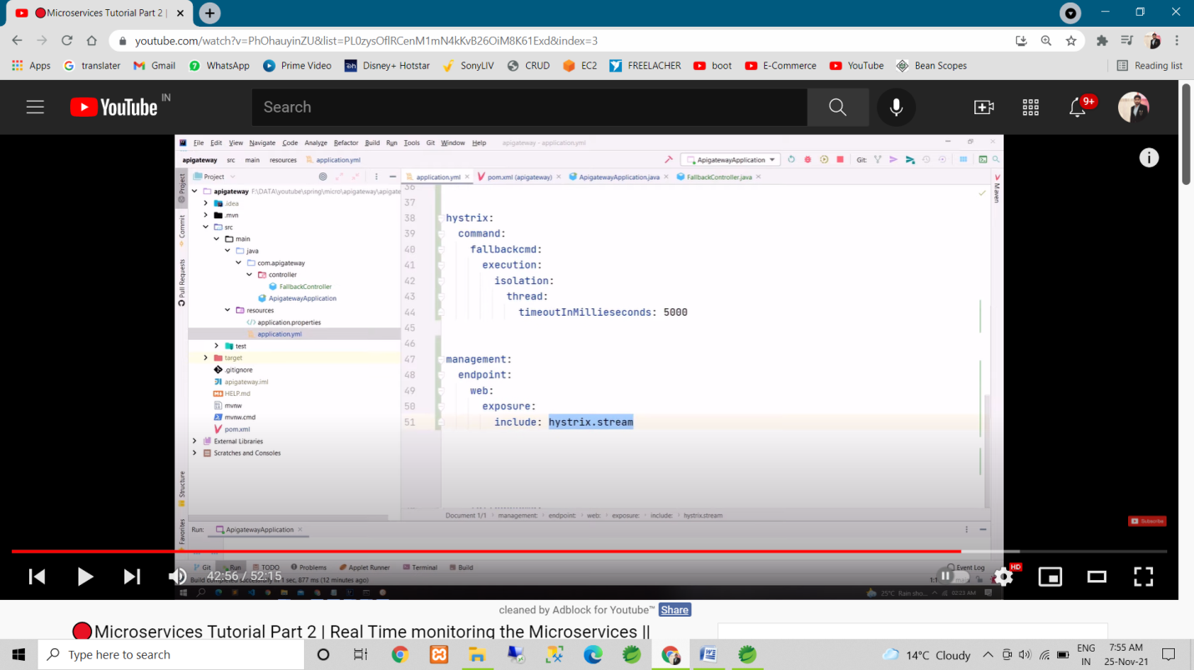

* Refer the following snap for the stream. So now our stream is enabled.

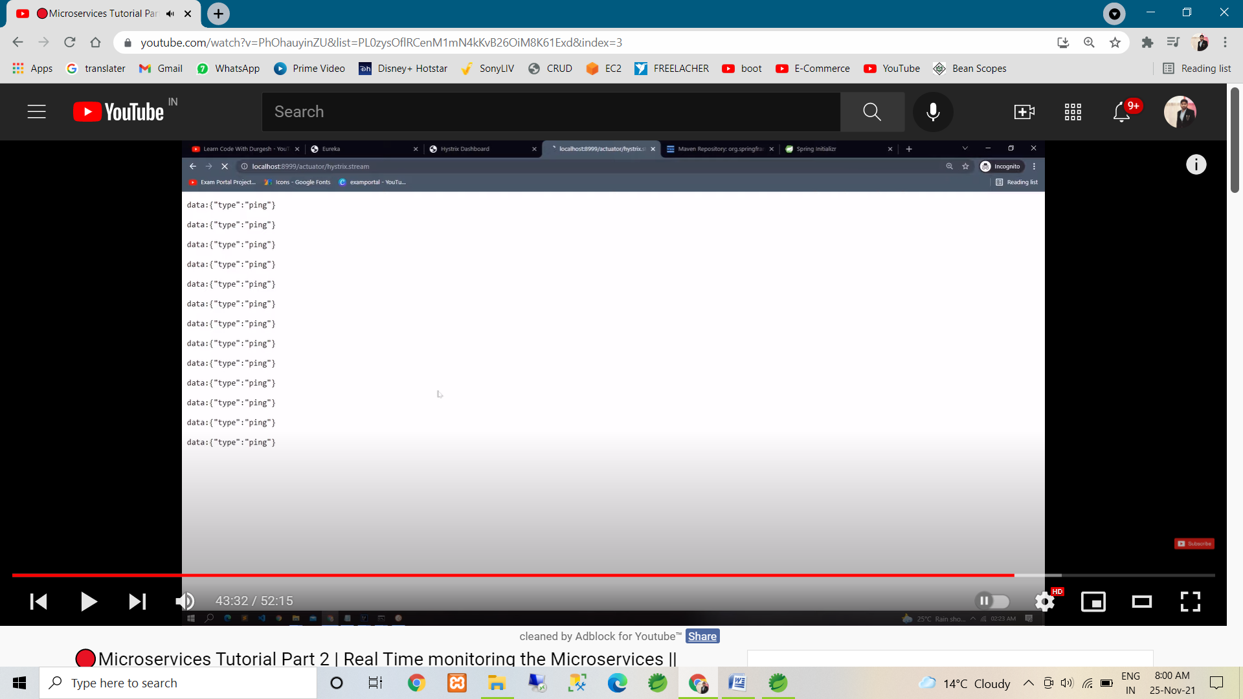

* We can give this stream to hystrix dash board so it’s can monitor it.
* So copy this stream url (:. localhost:8999/actuator/hystrix.stream) & giv e to dash board.
* & paste into hystrix dash board ui in, input filed. Refer the following snap.

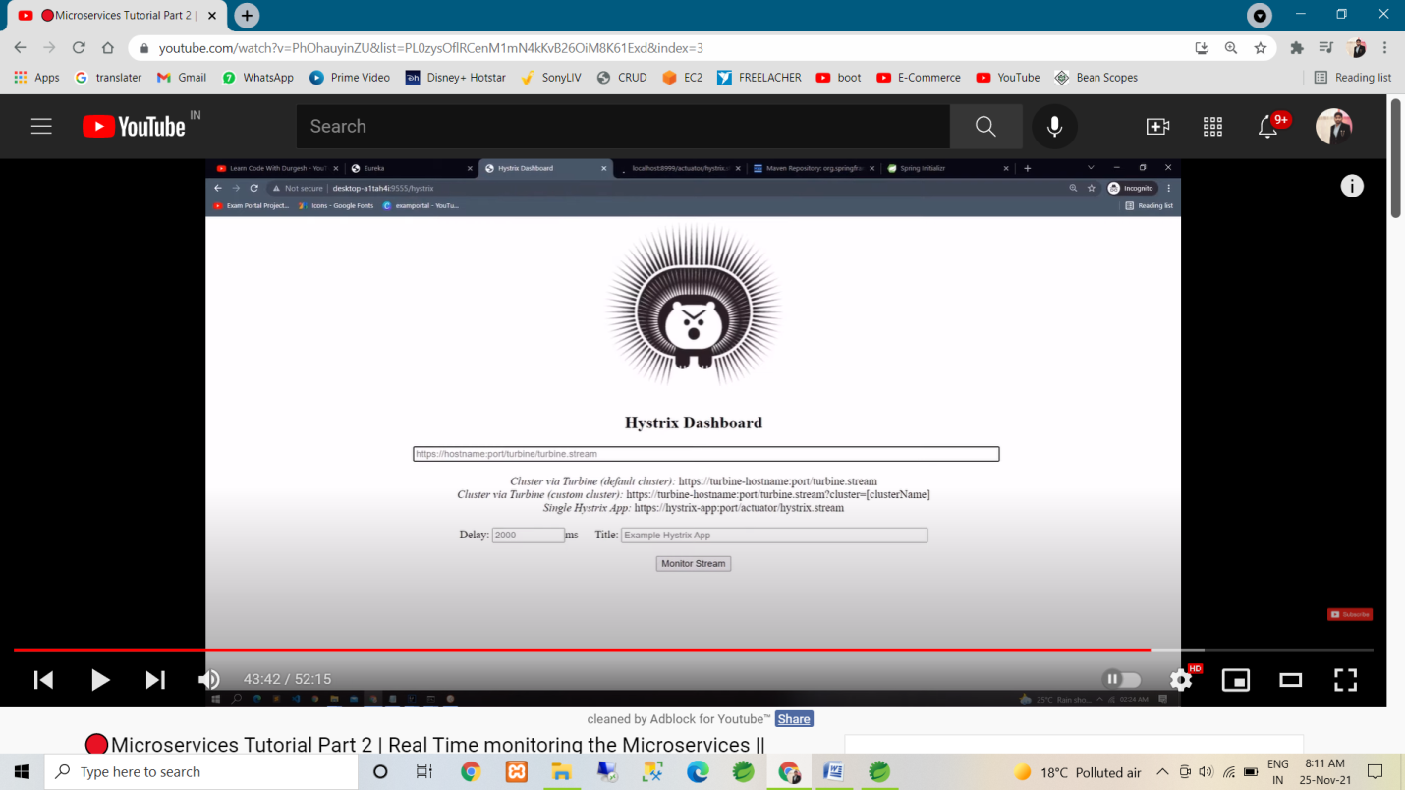

🡪 & client on monitor stream.

🡪after click on monitor button if the we get the issue so use the application.yml in hystrix-dashboard project. Refer the following snap.

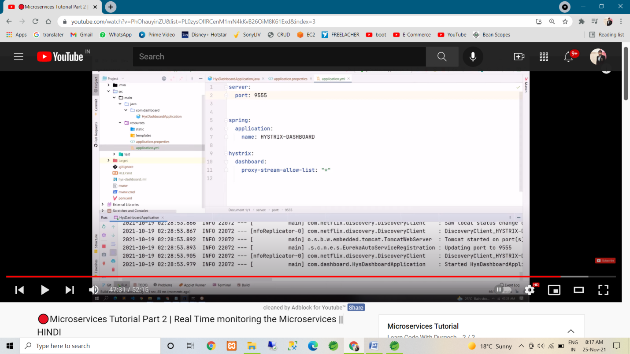

* After click on monitor following UI shown. Refer following snap.

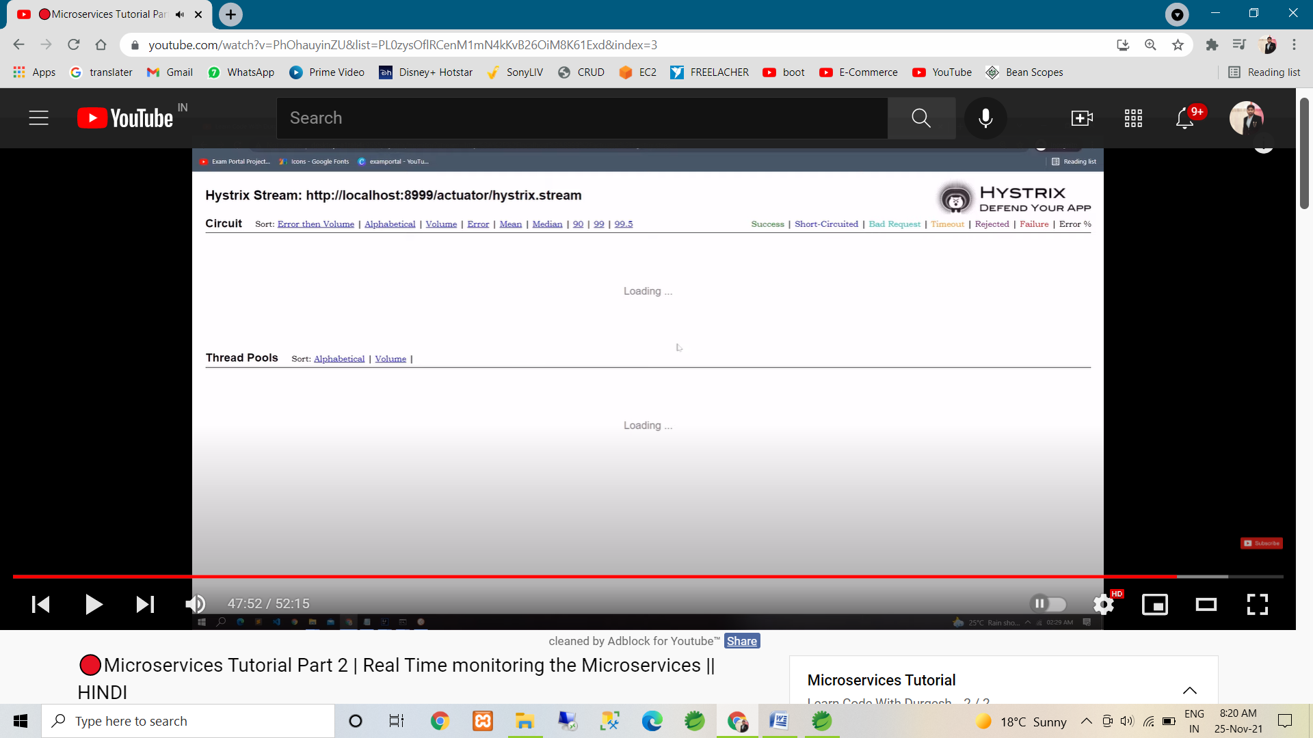

* Now we fire any request in micro service, in dash board we can monitor it.
* Refer following snap.

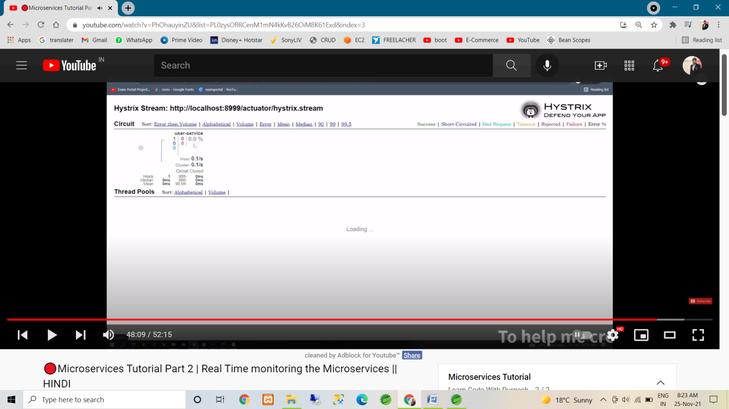

🡪if user service is down so we get the message ‘user service is down at this time !!’.

Refer following snap, if we fire any request in microservice so this type of graph generate.

